**Stress-Free Moves: Insider Secrets to Easy Transport and Relocation**

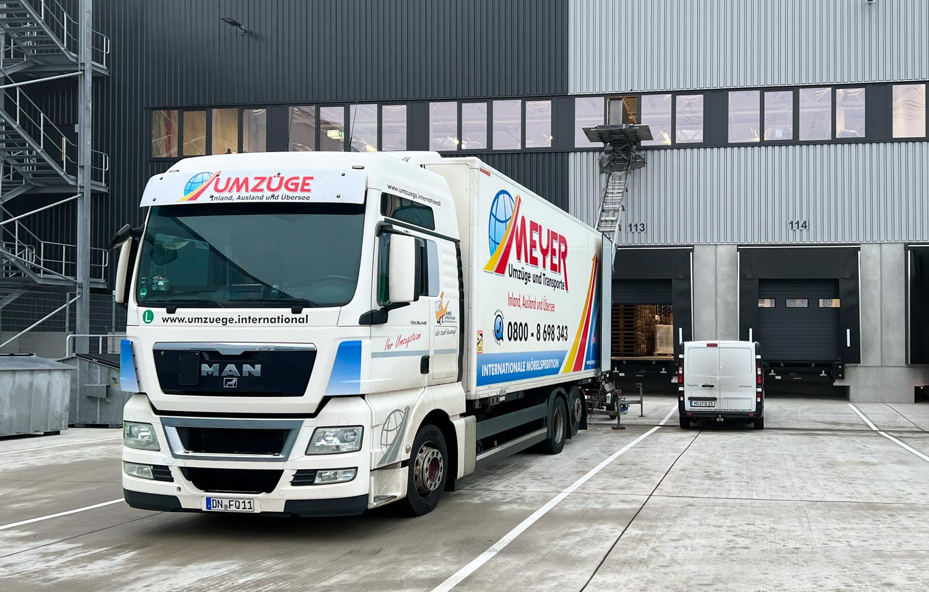

**Moving can be a daunting and overwhelming task, but it doesn't have to be. With the right preparation, mindset, and strategies, you can turn what is typically a stressful experience into a smooth and hassle-free process. In this comprehensive guide, we will share insider secrets and practical advice to ensure that your next move is as easy and efficient as possible.**

**The Importance of Early Planning**

**The foundation of a successful move begins with** [**Transporte und Umzüge**](https://ha-fa.de/transporter-mieten-umzug/) **early planning. The sooner you start organizing and preparing for your relocation, the better the outcome will be. Begin by creating a moving checklist that outlines every task you need to accomplish before the big day. This list should include decluttering, packing, booking movers or transportation, and arranging utilities at your new home.**

**Pro tip: Break down your moving checklist into weekly tasks to avoid last-minute chaos. This will keep you on track and reduce the overwhelming feeling of trying to do everything at once.**

**Creating a Timeline for Your Move**

**Once you’ve decided on a moving date, work backward and create a detailed timeline. Include important dates such as:**

* **Decluttering: Aim to complete this task at least four weeks before the move.**
* **Packing: Start packing non-essential items about three weeks prior to the move.**
* **Confirming movers or trucks: Make sure to confirm your moving company or truck rental about two weeks before the big day.**
* **Utility transfers: Arrange for your utilities to be transferred or set up a week before moving in.**

**Having a set timeline reduces last-minute stress and ensures you cover all bases ahead of time.**

**Decluttering Before the Move**

**Decluttering is a vital part of moving that is often overlooked, but it is one of the best ways to reduce stress and make your move easier. Moving items that you no longer need or want wastes time, energy, and money.**

**How to Effectively Declutter**

**Begin by sorting your belongings into four categories: Keep, Donate, Sell, and Discard. It’s important to be ruthless during this process. If you haven’t used an item in the past year, consider whether you really need to take it with you to your new home.**

* **Keep: These are the items you absolutely need or love and will take with you.**
* **Donate: Items that are in good condition but you no longer need can be donated to charity.**
* **Sell: High-value or gently used items can be sold online or at a garage sale.**
* **Discard: Anything broken, worn out, or no longer useful should be discarded.**

**By getting rid of unnecessary items, you'll have fewer things to pack and transport, which will significantly reduce the stress and cost of your move.**

**Hiring the Right Moving Company**

**Hiring the right moving company is one of the most important decisions you'll make. A reliable and professional mover can make all the difference in ensuring your relocation goes off without a hitch.**

**What to Look for in a Moving Company**

**When selecting a moving company, make sure to consider the following:**

* **Reputation: Read online reviews and ask for recommendations from friends or family.**
* **Licensing and insurance: Verify that the company is licensed and insured to protect your belongings.**
* **Experience: Choose a company with a proven track record, especially if you have specialty items like antiques, pianos, or artwork.**
* **Transparent pricing: Ask for an in-home estimate and ensure the company offers transparent pricing with no hidden fees.**

**Pro tip: Always get at least three estimates from different moving companies to ensure you're getting the best price and service for your move.**

**Packing Like a Pro**

**Packing is often the most time-consuming part of moving, but with a strategic approach, you can make it far more manageable. Start with the least-used rooms in your house, such as the attic, basement, or guest bedroom.**

**Packing Essentials and Materials**

**Make sure you have the following packing essentials before you begin:**

* **Sturdy boxes in various sizes**
* **Bubble wrap and packing paper for fragile items**
* **Packing tape and marker pens**
* **Labels to mark the contents of each box**

**Invest in quality packing materials to ensure your belongings are protected during transit. Fragile items should be carefully wrapped in bubble wrap or packing paper, and boxes should be filled to the top to avoid shifting during the move.**

**Labeling and Organizing Boxes**

**Label each box with its contents and the room it belongs in at your new home. This simple step will make unpacking much easier. Additionally, consider creating an inventory list for each box, so you know exactly what’s inside.**

**Pro tip: Color-code your boxes with labels for each room. For example, use red labels for kitchen items, blue labels for bedroom items, and so on. This will make it easier for your movers (or you) to place the boxes in the right rooms without having to open each one.**

**Transporting Specialty Items**

**If you have specialty items like artwork, antiques, or musical instruments, take extra care when preparing them for transport. These items require specific packing techniques and may need special handling by professional movers.**

* **Artwork and mirrors should be packed in custom boxes with corner protectors.**
* **Musical instruments like pianos and guitars should be transported by professionals who have the expertise to handle these delicate items.**
* **Antiques should be packed with high-quality materials and labeled as fragile to ensure they are handled carefully.**

**Consider purchasing additional insurance for high-value items to cover any potential damages during the move.**

**Managing Moving Day**

**Moving day can be chaotic, but with the right preparation, it can go smoothly. Start by packing an essentials box containing items you'll need for the first day at your new home, such as toiletries, a change of clothes, important documents, and basic kitchen supplies.**

**Communicating with Your Movers**

**If you're using a moving company, clear communication is key. Ensure the movers have the correct address, phone numbers, and any special instructions for handling certain items.**

**Pro tip: Offer the movers water and snacks to keep them energized and show appreciation for their hard work.**

**Settling into Your New Home**

**Once you've arrived at your new home, it’s tempting to jump right into unpacking everything at once, but it’s better to tackle it in stages. Start with the essentials and gradually work through each room.**

* **Begin by setting up the kitchen so you can cook meals without relying on takeout.**
* **Next, arrange the bedrooms so everyone has a comfortable place to sleep.**
* **Finally, focus on the living areas and storage spaces.**

**Unpacking at a steady pace will help you avoid feeling overwhelmed, and before you know it, your new home will feel comfortable and familiar.**

**Conclusion: A Stress-Free Move is Possible**

**Moving doesn’t have to be a stressful or chaotic event. With proper planning, organization, and the right approach, you can make your next relocation a smooth and stress-free experience. By following the insider secrets shared in this guide, you'll be well on your way to a successful, efficient, and easy move.**

**Remember, the key to a hassle-free relocation is preparation, so start early, stay organized, and enjoy the excitement of settling into your new home!**